The Excel Processor is an easy-to-use software application designed to make working with Excel files faster and more efficient. It automates common tasks like combining data from different sheets, formatting cells based on certain conditions, and cleaning up data to remove unnecessary rows. The tool is ideal for users who require efficient data processing, integration, and visualization within Excel workbooks.

Aayush Chavanke

Excel Processor :Information book &User Guide

A Time-Effort Saving Tool

Excel Processor: Information Book & User Guide

Simplifying Data Transformations

Table of Contents

1. **Introduction**
2. **Sheet Requirements**
   1. BOM_Master
   2. Stock_input
3. **Steps to Use the Application**
   1. Prepare the File
   2. Open the Application
   3. Provide Inputs
   4. Enter Data
   5. Process the Data
4. **Note**

# Introduction

The **Excel Processor** is a powerful Python-based application designed to automate and streamline various tasks associated with Excel file manipulation. It provides users with a comprehensive toolset for data integration, conditional formatting, data cleanup, and more, all within a user-friendly graphical interface built using tkinter.

# Purpose

The primary goal of the Excel Processor is to enhance productivity by automating repetitive and complex tasks that are commonly performed in Excel. By leveraging the capabilities of Python libraries such as pandas and openpyxl, this application enables users to efficiently manage and manipulate large datasets, ensuring accuracy and saving valuable time.

# Key Benefits

* **Automation of Routine Tasks:** Automates the integration and processing of data across multiple Excel sheets, reducing the need for manual intervention.
* **Enhanced Data Management:** Provides tools for conditional formatting and data cleanup, ensuring that the resulting datasets are clean and ready for analysis.
* **User-Friendly Interface:** Features a dynamic and visually appealing graphical user interface, making it accessible to users with varying levels of technical expertise.
* **Customization:** Allows for customization based on specific user requirements, including adjusting processing criteria and GUI preferences.

# Sheet Requirements

* BOM_Master
  + **Family**
  + **Model**
  + **Main item trim**
  + **Item Des**
  + **Item Trim**
  + **Component_Desc**
  + **Qty_Per_Assly**
  + **Buyer Name**
  + **Supplier Name**
* **Stock_input**

•**Item Trim  
• Component_Desc  
• Stock_on_hand**

The Software is case-sensitive. The Table name and the column name should be same as mentioned above. Although the user can change the sequence/order of the table Be cautious when entering data into these fields, as incorrect inputs will lead to incorrect outputs.

# Steps to Use the Application

## 1. Prepare the File

Create and save the XLSX file with the required sheets.  
Close the file.

## 2. Open the Application

Launch the Excel Processor app.  
Click on Browse to select your XLSX file.

## 3. Provide Inputs

After selecting the file, click on Provide Inputs.  
You will receive status updates in the message area.

## 4. Enter Data

The Excel file will open automatically with two new sheets: Model_Counts and Stock_analysis.  
Enter the necessary data, save, and close the file.

## 5. Process the Data

Click on Process.  
You will receive a message saying 'Final_Sheet created successfully' in the status area.  
Click on Open Final Sheet to view the Final_Sheet in the Excel file.

# Note:

If changes in input data are required, simply update, save, and close the file.  
Re-open the Excel Processor app, browse to select your file, and click Process directly.  
If you skip the Provide Inputs step, the Final_Sheet will be created based on the newly generated Model_Counts and Stock_analysis sheets with default values set to 0.

# Screenshots

## Initial Appearance

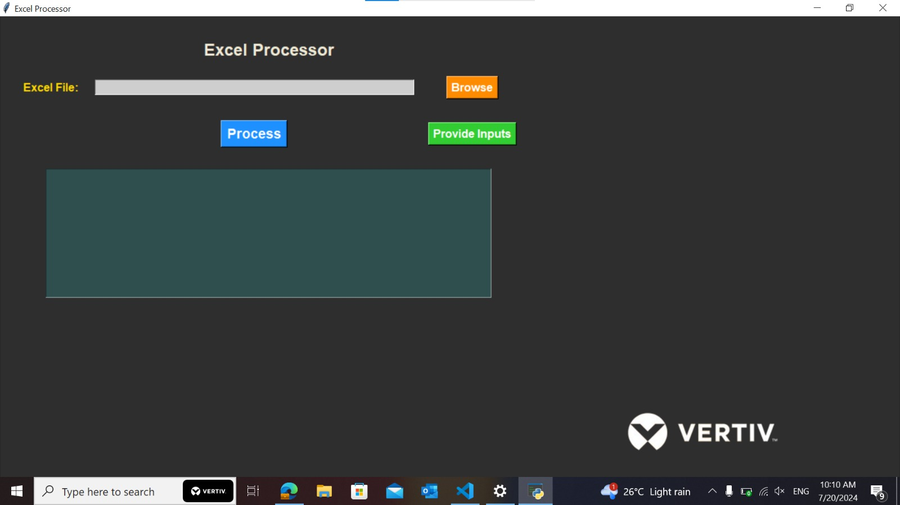

## Appearance in working state

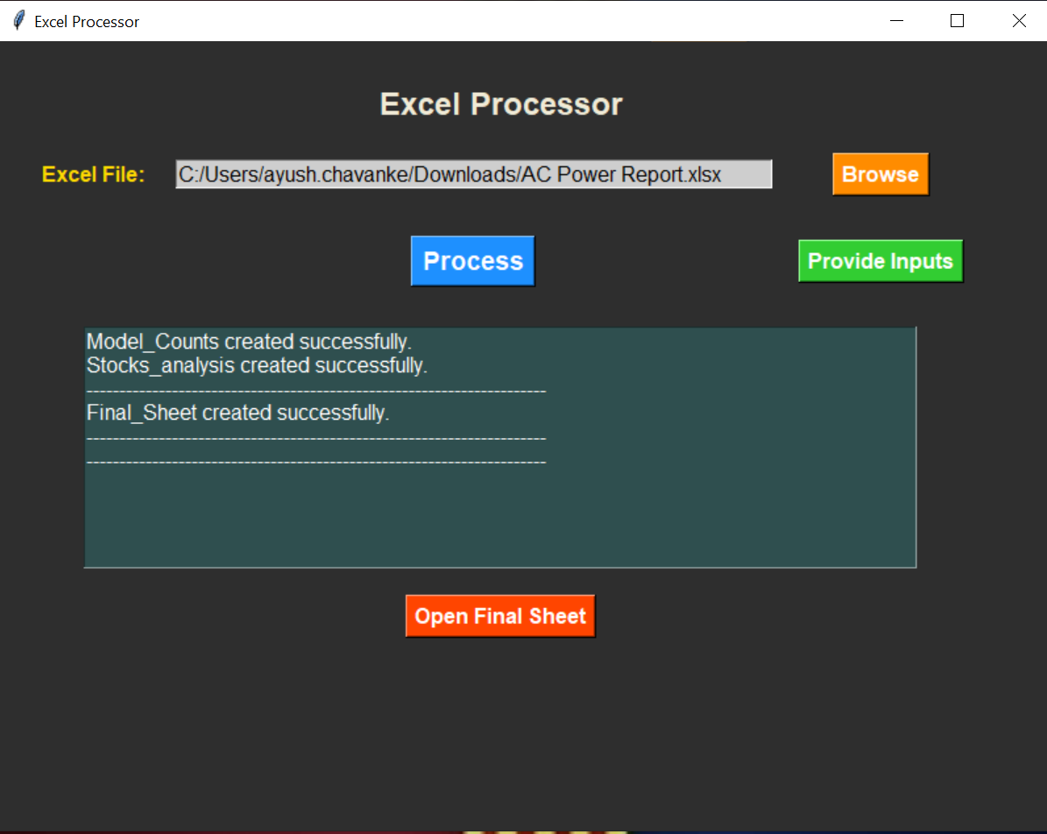

## Final Results:

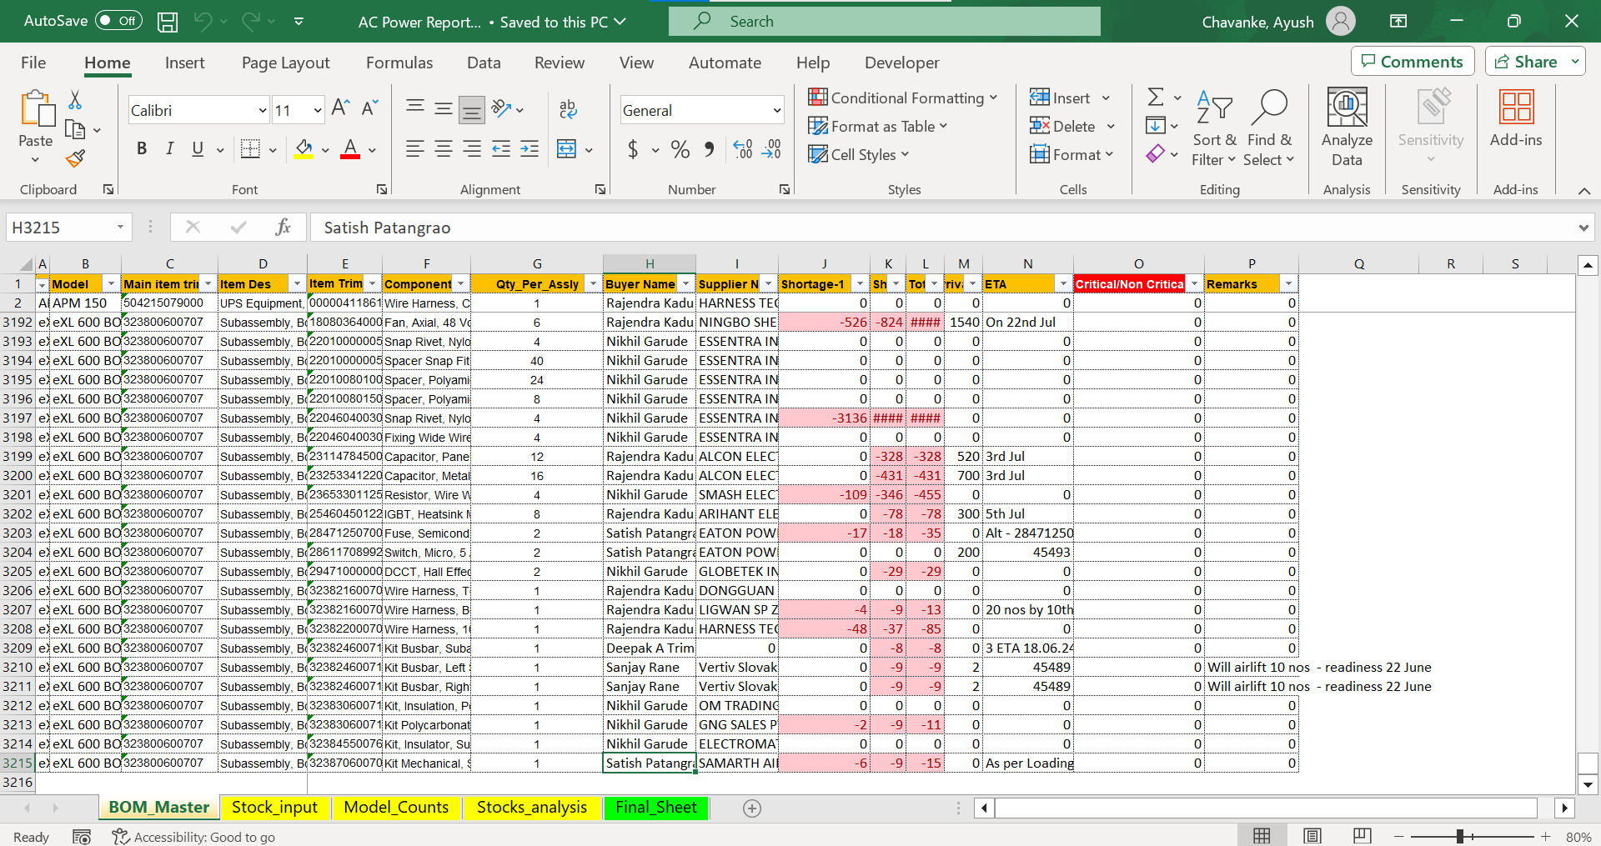

## We hope you have a great experience using the Excel Processor.

## We hope this application make your work with Excel files easier and more efficient.

## Thank you for choosing our application. If you have any questions or need support, please don't hesitate to reach out.

## Happy processing!

# Conclusion

For Further assistance/help/troubleshooting :

Contact : excelprocessor.helpdesk@gmail.com